**Stool Diary**

Name: Date of Birth:

**Instructions for completing a Stool Diary**

1. Write down every stool that is passed, these include in toilet, in underwear or nappy. Please also record stains or soiling.
2. In the Type column, write down the number from the Bristol Stool Chart that best describes the stool passed.
3. Fill in the diary for two whole weeks.
4. Every day discuss with child / family / school to check to make sure no stools were missed from the chart.
5. If prescribed any medication write what dose child took that day i.e. Macrogol (Movicol/Lactulose) Stimulant (Sodium Picosulfate/Senna).
6. Record the amounts of stool passed as lots/ some / little / drops / none.
7. In the Comments column, write down anything you think may be helpful to discuss in the child’s appointment, i.e. where dis child complain of pains – tummy bottom, before or during or after passing stool / sickness / blood passed.
8. If you are unable to use this chart, please download a free app to record as much information as possible before your child appointment.   
     
   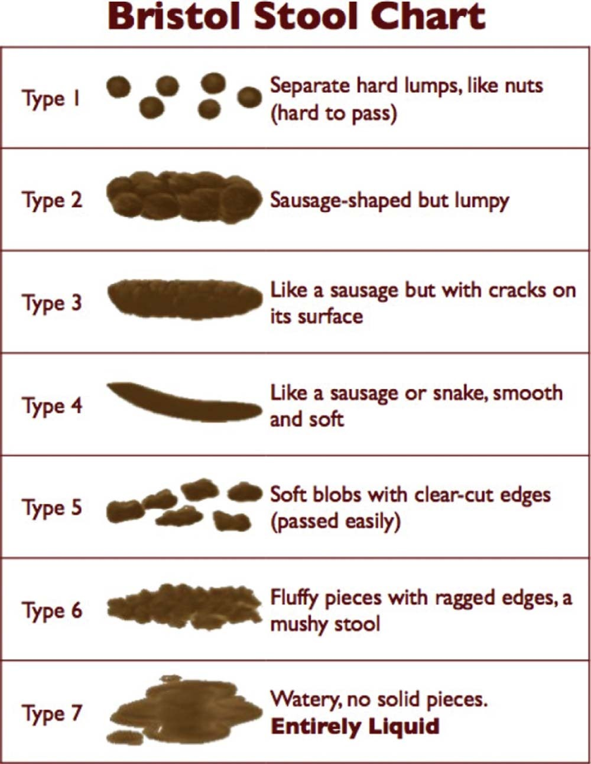

**Stool Diary**Name: Date Of Birth:

|  |  |  |  |  |  |  |  |
| --- | --- | --- | --- | --- | --- | --- | --- |
| **Date** | **Time of the day** | **Type of stool** (use Bristol stool number from Chart (1-7) | **Quantity of stool**  Lots (L)  Some (S)  Little (L)  Drops (D)  None (N) | **Pain/distress when passing stool**  Lots (L)  Some (S)  None (N) | **Where was the stool passed?**  Toilet (T)  Nappy (N)  Underwear (U)  Other (O) | **Pants soiled? - Type of soiling**  Marked (M)  Loose (L)  Solid (S)  None (N) | **Medication**  Macrogol (M)  Stimulant (S)  None (N) |
|  |  |  |  |  |  |  |  |
|  |  |  |  |  |  |  |  |
|  |  |  |  |  |  |  |  |
|  |  |  |  |  |  |  |  |
|  |  |  |  |  |  |  |  |
|  |  |  |  |  |  |  |  |
|  |  |  |  |  |  |  |  |
|  |  |  |  |  |  |  |  |
|  |  |  |  |  |  |  |  |
|  |  |  |  |  |  |  |  |
|  |  |  |  |  |  |  |  |
|  |  |  |  |  |  |  |  |
|  |  |  |  |  |  |  |  |
|  |  |  |  |  |  |  |  |
|  |  |  |  |  |  |  |  |
|  |  |  |  |  |  |  |  |
| Name and dose of prescribed Medication:  Any other comments: | | | | | | | |

**Stool Diary**Name: Date Of Birth:

|  |  |  |  |  |  |  |  |
| --- | --- | --- | --- | --- | --- | --- | --- |
| **Date** | **Time of the day** | **Type of stool** (use Bristol stool number from Chart (1-7) | **Quantity of stool**  Lots (L)  Some (S)  Little (L)  Drops (D)  None (N) | **Pain/distress when passing stool**  Lots (L)  Some (S)  None (N) | **Where was the stool passed?**  Toilet (T)  Nappy (N)  Underwear (U)  Other (O) | **Pants soiled? - Type of soiling**  Marked (M)  Loose (L)  Solid (S)  None (N) | **Medication**  Macrogol (M)  Stimulant (S)  None (N) |
|  |  |  |  |  |  |  |  |
|  |  |  |  |  |  |  |  |
|  |  |  |  |  |  |  |  |
|  |  |  |  |  |  |  |  |
|  |  |  |  |  |  |  |  |
|  |  |  |  |  |  |  |  |
|  |  |  |  |  |  |  |  |
|  |  |  |  |  |  |  |  |
|  |  |  |  |  |  |  |  |
|  |  |  |  |  |  |  |  |
|  |  |  |  |  |  |  |  |
|  |  |  |  |  |  |  |  |
|  |  |  |  |  |  |  |  |
|  |  |  |  |  |  |  |  |
|  |  |  |  |  |  |  |  |
|  |  |  |  |  |  |  |  |
| Name and dose of prescribed Medication:  Any other comments: | | | | | | | |