

Children’s Occupational Therapy Team

0191 455 5579

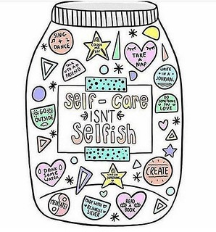

**Self-Care**

**(What does it mean?)**

**Self-Care**

Learning to look after yourself is the first step to developing independence. Self-Care includes washing, dressing, going to the toilet and eating and drinking.

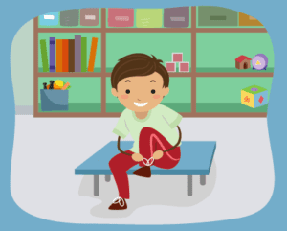

**Things to remember**

1. As tempting as it is don’t take over.
2. Break the task down into manageable chunks.
3. There are different ways to learn; show your child, tell your child and do the task with your child.
4. Problem-solve-together – don’t correct them if they make a mistake but ask them what they need to do to fix it.
5. Practice, practice, PRACTICE
6. Practice when you have time i.e. weekends or earnings.

