Children’s Community Nursing Team – Newborn Blood Spot Referral Form
All requested information MUST be completed otherwise referral will be rejected.

Name: |  | NHS:
DOB: | Gender: |  | Ethnicity/ Religion:
Address (inc Postcode): |  | Telephone Contacts:
Legal Responsibility - Names and Contact Details:  Mother’s Name:  Mother’s DOB:  Mother’s NHS: |  | Name of Alternative Carer and Address:
GP: |  | Health Visitor/ School Nurse:
Social Work Involvement: Y/N

Social Worker Name:

Reason for Referral & Nursing Intervention Required:
Date Child Health Notified: |  | Consent Obtained for Newborn Bloodspot:
Interpreter Required: |  | Newborn Bloodspot Card Provided to Family:
Source of Referral (Name & Telephone Number):
Date of Referral: Date of Visit:

Please contact the team to discuss all referrals prior to sending. Thank you.
Contact Details: 0191 2834660 or 07790934372
Referrals to be sent to: ghnt.referrals-gatesheadccnt@nhs.net
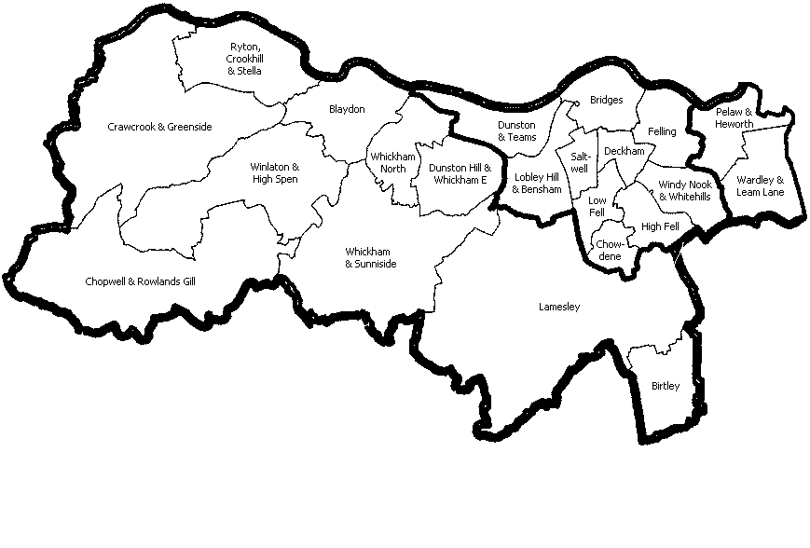
Gateshead Borough

