Children’s Community Nursing Team – Referral Form
All requested information MUST be completed otherwise referral will be rejected.

Name: |  | NHS:
DOB: | Gender: |  | Ethnicity/ Religion:
Address (inc Postcode): |  | Telephone Contacts:
Legal Responsibility: |  | Name of Alternative Carer and Address:
GP: |  | Health Visitor/ School Nurse:
Social Work Involvement: Y/N

Social Worker Name:

Reason for Involvement:

Child Protection/Child In Need/TAF?

Any Other Concerns?
Reason for Referral & Nursing Intervention Required:
Specific Parameters: |  | Respiratory Rate:
Heart Rate: |  | Oxygen Saturations:
Blood Pressure: |  | Weight:
Equipment sent home with Patient: Children must be sent home with one week’s supply of required equipment as CCNT do not have stock of items. These are ordered in on patient specific basis.
Medication List:
Significant Past Medical History:
When to seek further advice or return to hospital?

Specific Concerns?
Any Other Professional Involvement?

Consultants:

Specialists:
Dietician:

SALT:

Physiotherapist:

OT:
Source of Referral (Name & Telephone Number):
Date of Referral: Date of Visit:
Discharge Planning Meeting:
Consultant Responsible for Care:

Please contact the team to discuss all referrals prior to sending. Thank you.
Contact Details: 0191 2834660 or 07790934372
Referrals to be sent to: gan-tr.gatesheadccnt@nhs.net
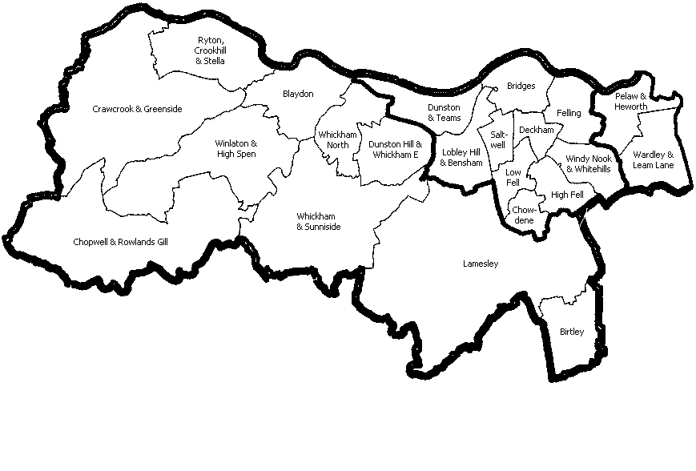
Gateshead Borough

