

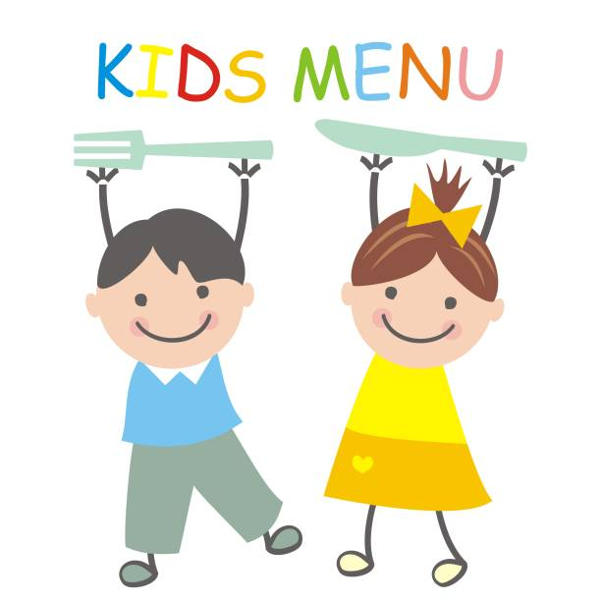

Children’s Occupational Therapy Team

0191 455 5579

**Cutlery**

|  |
| --- |
| 16,065 Techniques Word Images, Stock Photos, 3D objects, & Vectors |  ShutterstockThe Fault in Our Quotes - Practice Makes Perfect - WattpadPicky Eaters with ADHD: A Parent's Guide To Mealtime  It is important to make sure that the child has a good sitting position to allow them to concentrate and be as successful as possible with cutting. |
| juniorcaring_cutlery  These activities require both hands: one to support the activity and the other to do the activity. These can help practice the skills needed for cutting without the pressure of mealtimes. |